Mock Test 1

- If the total area of the circle is 80 cm², find the area of the shaded part.
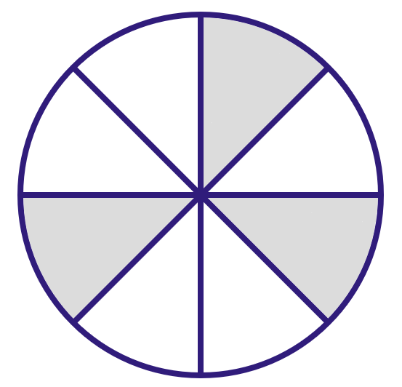
A) 30 cm²
B) 50 cm²
C) 20 cm²
D) 60 cm²
Difficulty level: M
Lesson: Shaded Areas
- What is the area of the shaded region if the side length of the big square is $4 cm$?
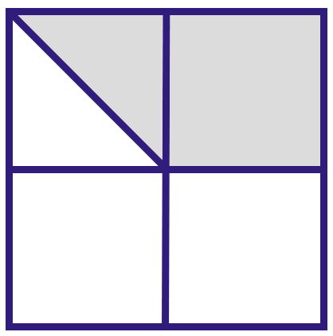
A) 8 cm²
B) 10 cm²
C) 6 cm²
D) 5 cm²
Difficulty level: M
Lesson: Shaded Areas
- Simplify: $(-x)^{11}$
A) $x^{11}$
B) $-x^{11}$
C) $11x$
D) $11-x$
Difficulty level: M
Lesson: Exponents
- Find the positive value of $x$ where: $\frac{1}{(x+8)^{4}}=\frac{1}{10000}$
A) 3
B) 18
C) 2
D) 6
Difficulty level: H
Lesson: Exponents
- If $7^{x-4}=1,$ then $x is$
A) 6
B) 7
C) 5
D) 4
Difficulty level: L
Lesson: Exponents
- Compare:
A | B
Area of triangle $ABC$ | Area of triangle $DBC$
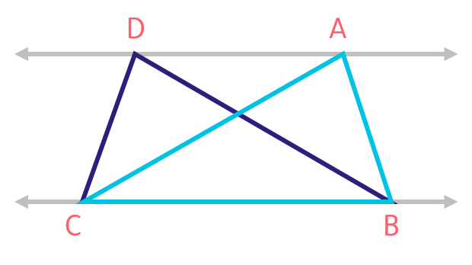
A) A
B) B
C) Equal
D) Not enough info
Difficulty level: M
Lesson: Triangles
- The side lengths of a triangle are in the ratio (2:2:3). What type of triangle is it?
A) Scalene triangle
B) Isosceles triangle
C) Equilateral triangle
D) Right triangle
Difficulty level: L
Lesson: Triangles
- $A$ and $B$ are similar circles with a radius of 6 cm. Find the length of $AB$.
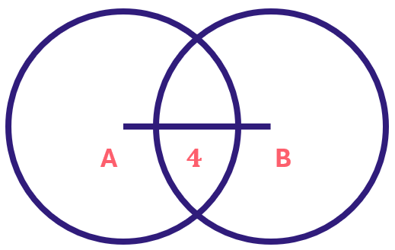
A) 6
B) 9
C) 12
D) 8
Difficulty level: L
Lesson: Circles
- Compare:
A | B
The difference between two consecutive even numbers | The difference between two consecutive odd numbers
A) A is greater
B) B is greater
C) Equal
D) Not enough info
Difficulty level: L
Lesson: Numbers & Order of Operations
- Complete the sequence: $3\frac{1}{2}, 5\frac{1}{3}, 7\frac{1}{4}, 9\frac{1}{5},….$
A) $10\frac{1}{10}$
B) $11\frac{1}{6}$
C) $12\frac{1}{4}$
D) $11\frac{1}{11}$
Difficulty level: H
Lesson: Numbers & Order of Operations
- The sum of 7 odd consecutive numbers is 7. What is the middle number?
A) -1
B) -2
C) 0
D) 1
Difficulty level: M
Lesson: Numbers & Order of Operations
- Complete the sequence $1, 2, 4, 7, 11, 16, …$
A) 20
B) 22
C) 21
D) 24
Difficulty level: L
Lesson: Numbers & Order of Operations
- Compare:
A | B
The largest prime factor of $130$ | $$15$$
A) A is greater
B) B is greater
C) Equal
D) Not enough info
Difficulty level: M
Lesson: Numbers & Order of Operations
- There are 6 cubes with a side length of 1cm in the opposite figure. Compare:
A | B
The number of cubes do we need to fill a cube with edge $5$ cm | $119$ cubes
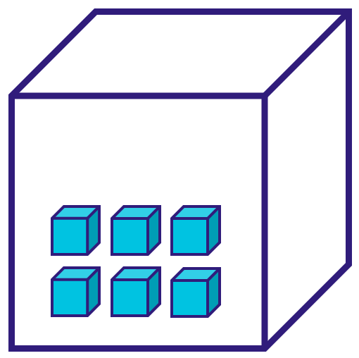
A) A is greater
B) B is greater
C) Equal
D) Not enough information
Difficulty level: M
Lesson: Areas, Perimeters & Volumes
- $ABCD$ is a rectangle where $AB=BH=3 cm$ and $HC=3BH$. Find the area of the rectangle?
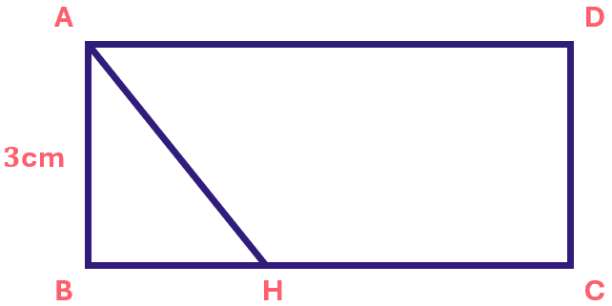
A) 36 cm²
B) 40 cm²
C) 12 cm²
D) 24${cm}^{2}$
Difficulty level: M
Lesson: Areas, Perimeters & Volumes
- Calculate $4×0.4×0.04×0.002=$
A) 1280
B) 0.128
C) 0.000128
D) 0.00128
Difficulty level: L
Lesson: Decimals
- Find $x$ in the following parallelogram.
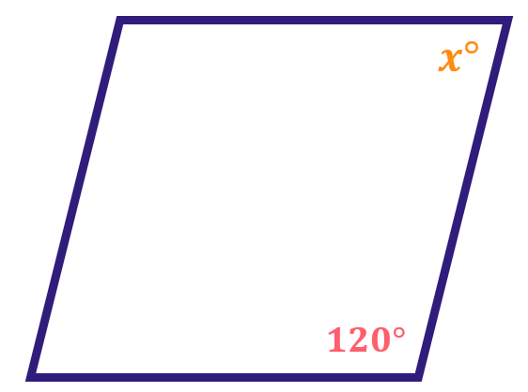
A) ${40}^{∘}$
B) ${60}^{∘}$
C) ${120}^{∘}$
D) ${90}^{∘}$
Difficulty level: M
Lesson: Polygons & Quadrilaterals
- If the ratio between $x :x^{2} is 2 :20$, what is the value of $x$?
A) 5
B) 10
C) 15
D) 20
Difficulty level: M
Lesson: Ratios & Percentages
- If zakat is 2.5% of the original amount, and the zakat paid was 160 SR, what was the original amount?
A) 6,400 riyals
B) 40,000 riyals
C) 3,200 riyals
D) 4,800 riyals
Difficulty level: M
Lesson: Ratios & Percentages
- Ali had 2400 SR and now he has 1800 SR, what percent of his original money did he spend?
A) $15\%$
B) $20\%$
C) $25\%$
D) $10\%$
Difficulty level: L
Lesson: Ratios & Percentages
- Two circles, the first rotates 5 times per second and the other rotates 9 times per second. If the first rotates 45 times, how many times does the second circle rotate?
A) 45
B) 56
C) 81
D) 90
Difficulty level: M
Lesson: Proportions
- In the opposite figure, compare:
A | B
$$m(A)+m(B)$$ | $${125}^{∘}$$
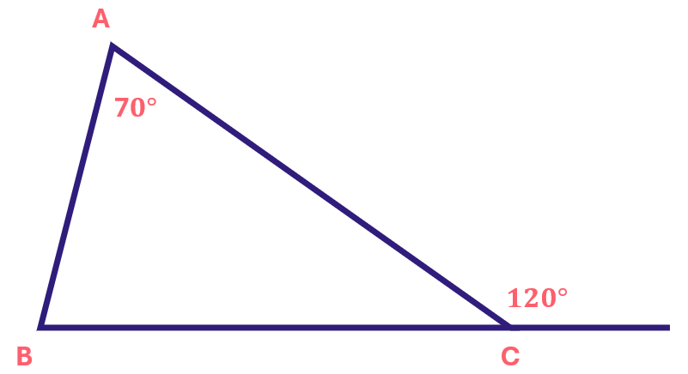
A) A is greater
B) B is greater
C) Equal
D) Not enough info
Difficulty level: M
Lesson: Angles
- Compare:
A | B
$$x°$$ | $$y°$$
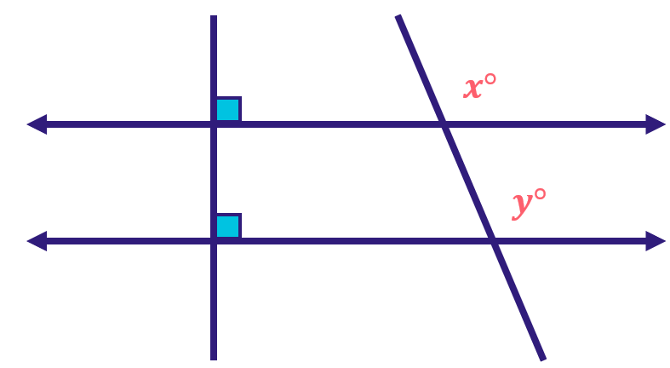
A) A is greater
B) B is greater
C) Equal
D) Not enough information
Difficulty level: L
Lesson: Angles
- If $0.7x+1.8y=2.8$, find the value of $14x+36y$.
A) 48
B) 56
C) 45
D) 60
Difficulty level: M
Lesson: Algebraic Expressions, Equations & Inequalities
- Let $1+2n>0,$ compare:
A | B
$$n$$ | $$\frac{-3}{4}$$
A) A is greater
B) B is greater
C) Equal
D) Not enough info
Difficulty level: H
Lesson: Algebraic Expressions, Equations & Inequalities
- If $x^{2}=1$, what is the sum of all possible values of x?
A) 2
B) 1
C) 0
D) 3
Difficulty level: M
Lesson: Algebraic Expressions, Equations & Inequalities
- Sahar is 30 years old. She has three sons whose ages are 0, 3, and 5. After 12 years, the total age of Sahar and her husband will be twice the total age of their three children. How old will her husband be after 12 years?
A) 45
B) 46
C) 50
D) 52 Years old
Difficulty level: H
Lesson: Algebraic Expressions, Equations & Inequalities
- If $x, y≠0$, compare:
A | B
$$x(y-7)+y(y-7)$$ | $$y(x+y)-7(x+y)$$
A) A is greater
B) B is greater
C) Equal
D) Not enough info
Difficulty level: L
Lesson: Algebraic Expressions, Equations & Inequalities
- If $5-2x<0$, compare:
A | B
$$x$$ | $$\frac{5}{2}$$
A) A is greater
B) B is greater
C) Equal
D) Not enough info
Difficulty level: M
Lesson: Algebraic Expressions, Equations & Inequalities
- The graph shows the sales of a clothing store. In which month did men’s clothing sales decrease compared with the previous month shown in the graph?
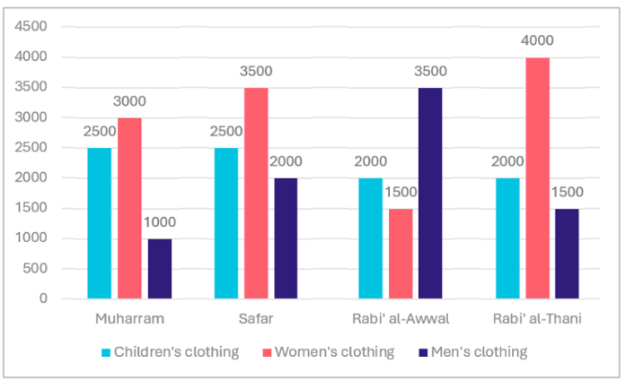
A) Rabi' al-Thani
B) Rabi' al-Awwal
C) Safar
D) Muharram
Difficulty level: L
Lesson: Data Analysis
- The figure shows the farm’s production over 7 years. The total production is 720 tons, and the production in the 3rd and 5th years is 80 tons altogether. By which year did the farm’s total production reach 440 tons?
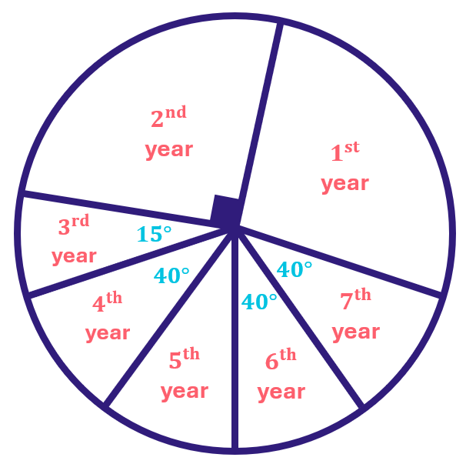
A) The third year
B) The fourth year
C) The fifth year
D) The sixth year
Difficulty level: H
Lesson: Data Analysis
- Based on the figure below, what was the percentage decrease in industries from 2001 to 2003?
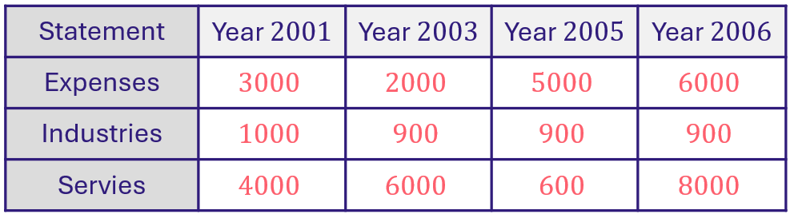
A) $5\%$
B) $10\%$
C) $20\%$
D) $15\%$
Difficulty level: M
Lesson: Data Analysis
- Which year range has car production closest to the production in 2001–2005?
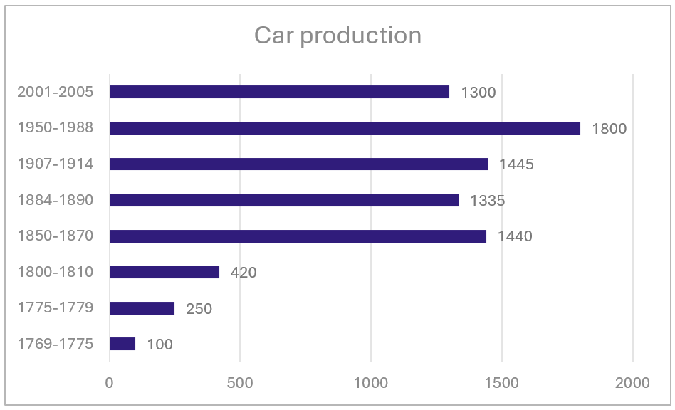
A) $1775-1779$
B) $1884-1890$
C) $1850-1870$
D) $1907-1914$
Difficulty level: L
Lesson: Data Analysis
- If a company sold 1 million vehicles in total, how many trucks and 4×4s did it sell in the same year?
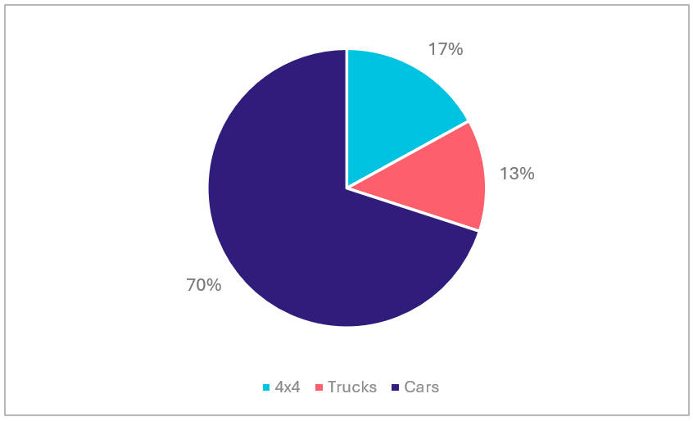
A) 20000
B) 333000
C) 300000
D) 150000
Difficulty level: M
Lesson: Data Analysis
- Emad traveled 220 km in 3 hours at a constant speed. How many hours will he need to travel 1100 km at the same speed?
A) 18
B) 10
C) 12
D) 15
Difficulty level: M
Lesson: Speed - Time - Distance
- Compare:
A | B
$$\frac{1}{2}+\frac{1}{3}$$ | $$\frac{1}{3+2}$$
A) A is greater
B) B is greater
C) Equal
D) Not enough info
Difficulty level: M
Lesson: Fractions
- When 9 is divided by $x$, the remainder is 2. Find a possible value of $x$.
A) 5
B) 6
C) 7
D) 9
Difficulty level: M
Lesson: Division
- Compare:
A | B
$$\sqrt{99}$$ | $$\sqrt{11}+\sqrt{51}$$
A) A is greater
B) B is greater
C) Equal
D) Not enough info
Difficulty level: M
Lesson: Roots
- Which number, if added to the table, would change the range?
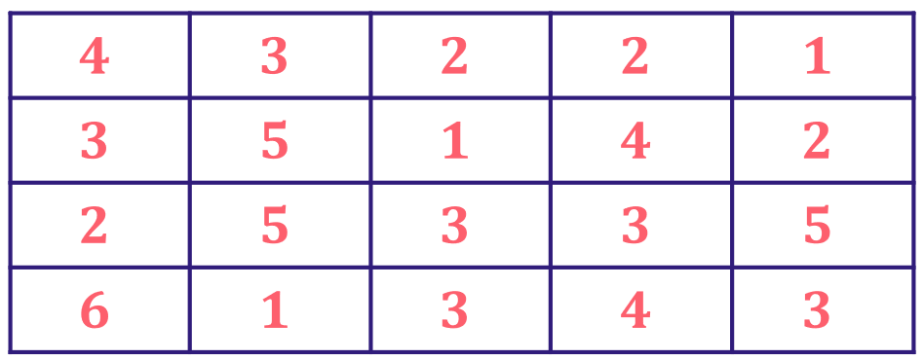
A) 3
B) 6
C) 4
D) 7
Difficulty level: M
Lesson: Statistics
- When writing numbers from 1 to 200, how many times does the digit 5 appear?
A) 20
B) 30
C) 40
D) 50
Difficulty level: L
Lesson: Numbers & Order of Operations
- What is the value of x, if ${ x}^{2 }=3^{-4}$
A) $±\frac{1}{9}$
B) $-\frac{1}{9}$
C) 9
D) 81
Difficulty level: L
Lesson: Exponents
- What is the measure of the larger interior angle at vertex $R?$
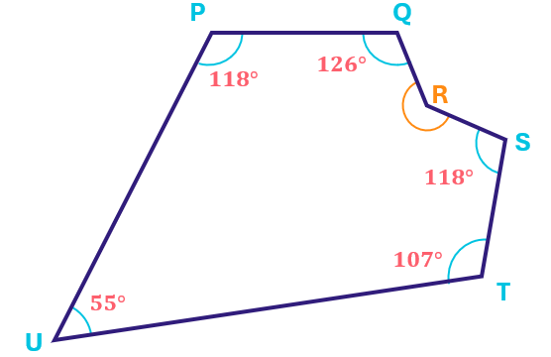
A) 164°
B) 188°
C) 204°
D) 196°
Difficulty level: H
Lesson: Polygons & Quadrilaterals
- $1^{100}+1^{0}= ?$
A) 2
B) 10
C) 3
D) 5
Difficulty level: L
Lesson: Exponents
- If $\frac{1}{2x+1}=\frac{1}{x+2}$, find the value of x.
A) 1
B) 2
C) -3
D) -2
Difficulty level: L
Lesson: Equations & Inequalities
- What is the remainder of 29 divided by 3?
A) 3
B) 1
C) 2
D) 7
Difficulty level: L
Lesson: Division
- Which of the following values is the greatest?
A) $\frac{\frac{\frac{1}{8}}{1}}{2}$
B) $\frac{\frac{\frac{3}{5}}{5}}{3}$
C) $\frac{13}{22}$
D) $\frac{18}{48}$
Difficulty level: M
Lesson: Fractions
- If we multiply $x$ by itself, then add twice $x$, we get:
A) $2x^{2}$
B) $x^{2}+2x$
C) $x+2x$
D) $x(x+1)$
Difficulty level: L
Lesson: Algebraic Expressions
- If a number is divided by 4 and then 4 is added to the quotient, the result is 8. What is that number?
A) 25
B) 35
C) 16
D) 54
Difficulty level: L
Lesson: Equations & Inequalities
- If $8x=64$, find $4x$.
A) 8
B) 14
C) 22
D) 32
Difficulty level: L
Lesson: Equations & Inequalities
- If the ratio of $x$ to $x^{2}$ is $4:40$, find the value of $x$.
A) 10
B) 5
C) 21
D) 4
Difficulty level: L
Lesson: Percentages & Ratios

Mock Test 1 - Answer Key

Q# | Answer | Q# | Answer
1 | A | 26 | C
2 | C | 27 | B
3 | B | 28 | C
4 | C | 29 | A
5 | D | 30 | A
6 | C | 31 | B
7 | B | 32 | B
8 | D | 33 | B
9 | C | 34 | C
10 | B | 35 | D
11 | D | 36 | A
12 | B | 37 | C
13 | B | 38 | B
14 | C | 39 | D
15 | A | 40 | C
16 | C | 41 | A
17 | B | 42 | D
18 | B | 43 | A
19 | A | 44 | A
20 | C | 45 | C
21 | C | 46 | C
22 | B | 47 | B
23 | C | 48 | C
24 | B | 49 | D
25 | A | 50 | A

